DINESH SHANMUGAM  No. 1/49 Angalaman Koil Street,  Arasur Post  Alankuppam  Ulunderpet Taluk  Viluppuram-Dist  Email:dineshshanmathi@gmail.com  Mobile no. 9626479490 | 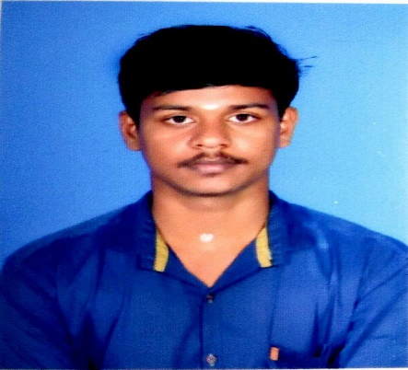

Career objectives

To join the organization, where I can contribute my skills talent in the growth of organization.

Academic Qualification

DEGREE | School / College | Year of Passing | Percentage  /CGPA
B.E (ECE) | Adhiyamaan College of Engineering, Hosur | Pursuing | 7.82  ( CGPA Upto 6th Sem)
H. S. C | John Dewey Matric Higher Secondary  School, Villupuram | 2014 | 84.91
S. S. L. C | John Dewey Matric Higher Secondary  School, Villupuram | 2012 | 84.6

Subject Expertise
- Language: C, Java
- Programming: VHDL Programming

Area of Interest
- Embedded System

Certificate of Merits
- Attended Internship Program for ARICENT –ARISE under the aegis of NASSCOM Foundation, organised by iPrimed , Bangalore for three months, during 2017
- Presented a paper entitled as ZIGBEE Based Home Automation System, in the National Conference NCIRSEM’17 organised by P.S.V College of Engineering and Technology on 27th & 28th April 2017.
- Presented a paper entitled as Brain Finger Printing in the National level student conference on Innovative trends in Instrumentation, Electronics and Instrumentation Engineering, BSA Crescent University, Held on 4th April 2017.
- Attended In-Plant Training in Manufacturing Operation for the period from 30.12.2016 to 31.12.2016 at Lenovo, Pondicherry.

Project Details

- Title : Zigbee based home automation system.
- Domain : Emebedded System.
- Description : A Zigbee based home automation system and wireless network are integrated through a common home gateway. The home gateway provides network interoperability, a simple and flexible user interface and remote access to the system.

Personal Details

Date of Birth : 01-02-1997.
Father’s Name : Shanmugam.S
Mother Name : Banumathi S
Present Address : GVKR Building,Kamaraj Colony,Hosur, Tamil Nadu
Permanent Addreess : No:1\49 Angalamaan kovil(st), Arasur(post), Alangkuppam.
Languages Known : English, Tamil.( Read and Write)
Hobbies : Cooking, Playing Cricket

Declaration

I hereby declare that the details furnished above are true to the best of my Knowledge.
Place : Sincerely
Date : [ ]

